**SarADC Module Description Document**

**1. Introduction**  
The SarADC (Successive Approximation A/D Converter) is mainly used for measuring DC voltage. Its basic structure is shown in Figure 1. It is primarily applied in the following three scenarios:

Collecting the relative voltage on a certain GPIO pin with respect to VDD33, without concern for the absolute voltage value of either VDD33 or the GPIO pin. For example, ADC key applications.

Collecting the absolute voltage on a certain GPIO pin, where the measured value should be independent of the current VDD33 level. For example, measuring battery voltage through a GPIO pin.

Collecting the absolute voltage of Vin, where the measured value should be independent of the current VDD33 level, and should accurately capture the Vin input voltage within the range of 2.60 V to 5.00 V.

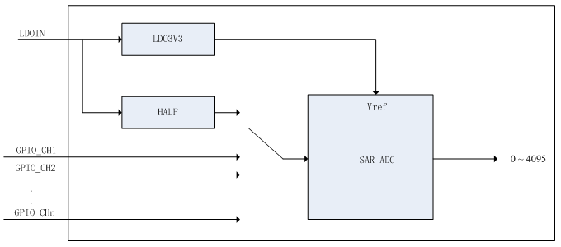

Figure 1 ADC Functional Block Diagram

**2. Typical Application**  
**Obtaining the relative voltage of GPIO:**

SarAdcGpioSel(ADC_CHANNEL_B22);// Configure GPIOB22 as an ADC channel

adcvol = SarAdcChannelGetValue(ADC_CHANNEL_B22);// Get the ADC sampled voltage